Two-year-old news

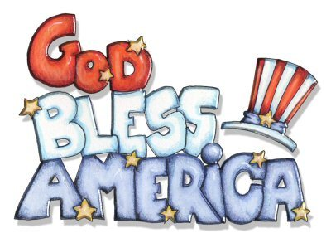

Hello Parents,

In July we will be celebrate America’s Birthday. Then learn about God and about water. We will continue to review shapes, colors,letters, and numbers. Remember every Friday is a fun Friday! With different themes. We had so much on Foam Day. An on Movie Day. Please check out our Facebook Page for pictures of our adventures! Potty Training is going great! Please continue to send in extra change of clothes. I truly appreciate the support. If you have any question, please feel free to leave me a note with office.

**Important dates to remember**

No School on July 3

July 10 Card Board City

July 17 Treasure Hunt Day

July 24 Wacky Hat Day

July 31 PJ Day

**Reminders –**

Ensure your child has enough changes of clothes and underwear, as teachers encourage potty training. Make sure your child’s belongings has their name written inside.