# 3

Dear Family,
A Bay’s vision is suited to social interaction right from birth. Babies can focus fairly well on objects that are 9-14 inches away. This is about the distance of your face when you are holding your baby in a cradle position. A baby’s ability to see your face plays a primary role in bonding.

Mrs. Debbie and Ms. Melanie

Week 1 | Ball Track Designs
Week 2 | Color Day
Week 3 | It Takes Two
Week 4 | Class Photo’s
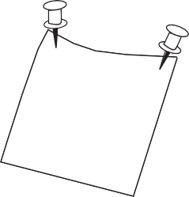

Baby Room October
Theme

Important Dates:
10/4-8 Fire Prevention and Safety week
10/19 Lion’s Club Vision Screening
10/26-28 Picture Day
10/29 Fall Fun Day

Birthdays and Milestones:
10/1 Happy First Birthday Raelynn

Classroom Needs:
Please Make sure you have 2 outfits.
We will also need a clean bottle for every feeding while they are with us
Please label all items that is brought for your child
Also please it us know if there is any changes in the feeding schedules.

